IT’S OUR TURN TO EAT
The Story of a Kenyan Whistleblower

Michela Wrong

Original Trade Paperback

Published 23rd February 2009 Price £12.99

‘An important and thrilling book. Out of the dramatic story of one noble but very human Kenyan choosing between his moral conscience and his ethnic loyalties, Michela Wrong deftly paints a damning portrait of Western complicity in an entire continent’s losing battle with corruption’
John le Carre

‘Powerful and moving, ‘It’s Our Turn to Eat’ has the pace and tension of a thriller, and the moral force to command attention’
Paul Collier

When Michela Wrong’s Kenyan friend John Githongo appeared one cold February morning on the doorstep of her London flat, carrying a small mountain of luggage and four trilling mobile phones he seemed determined to ignore, it was clear something had gone awry in a country regarded until then as one of Africa’s few success stories.

Two years earlier, in the wave of euphoria that followed elections marking the retirement of long-serving President Daniel arap Moi, John had been appointed Kenya’s new anti-corruption czar. In choosing this fearless anti-corruption crusader with a booming laugh, the new government signalled its determination to end the practices that had made Kenya an international byword for sleaze.

But now John was on the run, having realised that Kenya’s new administration, far from breaking with the past, was using near-identical techniques to pilfer public funds. John’s tale, which has all the elements of a political thriller, is the story of how a brave man came to make a lonely decision with huge ramifications.

Probing the cultural and historical factors at the heart of the continent’s crisis, It’s Our Turn to Eat explores questions that have troubled outsiders for decades. What is it about African society that makes corruption so hard to eradicate, so devastating in its impact? Why have African leaders found it so easy to reduce political discussion to the self-serving calculation of which tribe gets to ‘eat’? And when will Africans place society’s wider interests ahead of their ethnic community’s narrow needs?

ABOUT THE AUTHOR
Michela Wrong is a distinguished international journalist, and has worked as a foreign correspondent covering events across the African continent for Reuters, the BBC and the Financial Times. Her first book, In the Footsteps of Mr Kurtz, won the PEN James Sterne Prize for non-fiction. Her second, I Didn’t do it for You, is a portrait of the African nation of Eritrea.
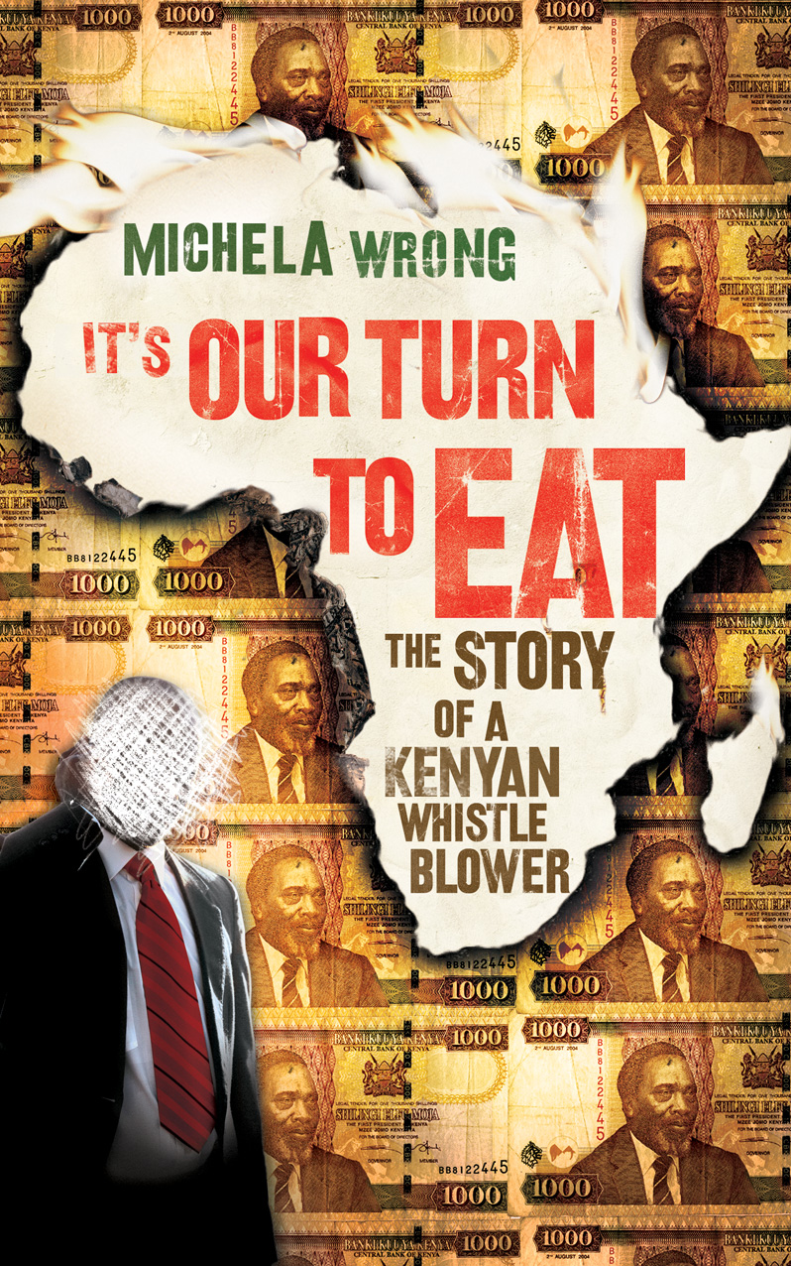
For more information please contact Patrick Hargadon
on 020 8307 4067 or email patrick.hargadon@harpercollins.co.uk

